3D Metaphor for Interactive Visual Analytics
Of Social Media Data

P. M. Ranathunga

3D Metaphor for Interactive Visual Analytics
Of Social Media Data

P. M. Ranathunga
Index No : 13000993

Supervisor: Dr. Prasad Wimalaratne

December 2017

Submitted in partial fulfillment of the requirements of the
B.Sc in Computer Science Final Year Project (SCS4124)

Declaration
I certify that this dissertation does not incorporate, without acknowledgment, any material previously submitted for a degree or diploma in any university and to the best of my knowledge and belief, it does not contain any material previously published or written by another person or myself except where due reference is made in the text. I also hereby give consent for my dissertation, if accepted, be made available for photocopying and interlibrary loans, and for the title and abstract to be made available to outside organizations.

Candidate Name:

………………………………………………
Signature of Candidate Date: 24.05.2018

This is to certify that this dissertation is based on the work of

Mr. P M Ranathunga

Under my supervision. The thesis has been prepared according to the format stipulated and is of an acceptable standard.

Supervisor Name:

………………………………………………
Signature of Supervisor Date: 24.05.2018

Abstract
Social media is a platform where people share their views, ideas, sentiments, and emotions every day. The popularity of social media has been growing over the past few years. Every day social media generates large number data from users. Extracting and interpreting information from user-generated data is a trending topic in the scientific community and the business world. Numerous web applications that deal with processing and the visualization of user-generated content have proved the importance of social media data visualization. Visualizing those data is not an easy task. Every day people are trying come up with new ways to visualize these data which will help to analyze them more closely.

In this dissertation, an interactive 3D metaphor to visualize social media data in a 3D environment using WebGL is introduced. This visualization is mainly based on the geolocation where users can analyze the social media data based on the geolocation. After making some improvements, we can use this 3D metaphor for other social media data as well.

In this dissertation, the evaluation was done using a qualitative approach. Shared an online survey on internet and participants had an experience with a 2D and 3D metaphor which has hosted on the internet. From that user got a chance to experience the proposed metaphor in their environment. There were totally 37 participants who have completed the survey successfully. More than 50% of participants had mentioned that proposed 3D metaphor is suitable to visualize social media data, in this case, twitter data.

Preface
The basis for this research originally stemmed from my passion for developing better methods of interactive data visualization for social media data. Since implementing a metaphor to analyze social media trending field in computer science world, though to give a try to introduce a novel approach to visualize social media data using an interactive 3D metaphor.

Some of the concepts identified in the literature review has been used in the context, and those are justified and referenced accordingly. Sample data was collected from the Twitter API, and all maps are open sourced resources. I carried out the analytical calculation in the results and evaluation chapter under the supervision of my supervisor.

Acknowledgement
Doing research is not a simple task, it needs great support and strengths from others. Those people may give me courage and support to success this research from various ways. That can be guiding me through out the research, or that can be a simple discussion about my research and ask how the progress is now? There are significant individuals that I should thank from my heart,
Thank You to…
Dr. Prasad Wimalarathne for being my supervisor and guardian of my research.
(Having me as student is a very difficult task, but he endured all the troubles and always look out for me)
My friends (Ashan, Chamath, Wishwa, Maneesha, Maneesha Perera Nathaliya) who has always reminded me to that I have research to do
My other friends who have helped me to conduct my evaluation successfully.
My lovely parents for all support and strength gave me by being my shadow for all these years and my lovely sister.

P. M. Ranathunga
University of Colombo School of Computing

Table of Contents

Declaration i
Abstract ii
Preface iii
Acknowledgement iv
Table of Contents v
List of Figures vii
List of Acronyms viii
Chapter 1 - Introduction 1
1.1 Background to the Research 3
1.2 Research Problem and Research Questions 3
1.3 Justification for the research 4
1.4 Methodology 4
1.5 Outline of the Dissertation 5
1.6 Delimitations of Scope 6
1.7 Summary 6
Chapter 2 - Literature Review 7
Chapter 3 - Design 10
3.1 Introduction 10
3.2 Data Acquisition 10
3.2.1 Twitter REST API 11
3.2.2 Harvesting Machine 12
3.2.3 Data JSON 13
3.3 Data Preprocessing 13
3.4 3D Visualization 14
3.4.1 Implementing 3D Metaphor 15
3.4.2 Mapping Tweets 15
3.4.3 Visualizing 16
3.5 Evaluation 16
3.6 Summary 17
Chapter 4 - Implementation 18
4.1 Introduction 18
4.2 Implementation 18
4.3 Summary 22
Chapter 5 - Results and Evaluation 23
5.1 Introduction 23
5.2 Evaluation Model 23
5.3 Results 26
5.4 Summary 30
Chapter 6 - Conclusions 31
6.1 Introduction 31
6.2 Conclusions 31
6.3 Limitations 32
6.4 Implications for further research 32
References 33
Appendix A: Diagrams 36
Appendix B: Code Listings 40

List of Figures
Figure 1.1 Difference between 2D and 3D visualization[9] 3
Figure 1.2 High-level architecture of proposed research methodology 5
Figure 3.1 Data acquisition diagram 10
Figure 3.2 Sample twitter response 12
Figure 3.3 Data preprocessing diagram 13
Figure 3.4 Preprocessed twitter respond 14
Figure 3.5 Tweets mapping icons chart 16
Figure 4.1 Initial user interface 18
Figure 4.2 Interface of country view 19
Figure 4.3 Import eeGeo JS 19
Figure 4.4 Python function for tweets extraction 20
Figure 4.5 Data preprocessed function 21
Figure 4.6 Create custom marker in leaflet JS 21
Figure 4.7 addMarker function 21
Figure 5.1 2D map used in evaluation survey 24
Figure 5.2 2D map after several zoom levels 25
Figure 5.3 3D map used in evaluation survey 25
Figure 5.4 3D map after several zoom levels 26
Figure 5.5 Gender statics graph 27
Figure 5.6 Age group statics graph 27
Figure 5.7 Feature rating graph for 2D metaphor 27
Figure 5.8 Feature rating graph for 3D metaphor 28
Figure 5.9 Metaphor rating statics graph 28
Figure 5.10 Icon rating statics graph 29
Figure 5.11 Performance testing results for 3D metaphor 29
Figure 5.12 Performance testing results for 2D metaphor 30

List of Acronyms

IVA - Interactive Visual Analytics
VA - Visual Analytics
JSON - JavaScript Object Notation
REST - Representational state transfer
API - Application programming interface
UI – User Interface
JS – JavaScript
HTML - Hypertext Markup Language
CSS - Cascading Style Sheets

Introduction
Visualization already plays a crucial role in data science, helping data scientists make sense of the structure and underlying patterns that may be held within the data, even before any serious computation begins. Wang Lidong research conclusion states that interactive visualization helps to gain great insight from big data [1].

Even though social media data contains valuable information, it is not possible to make decisions by looking at raw social media data because it is impossible to identify any patterns. However, when it is presented in an understandable way that anyone can understand and that data become useful. Data visualization is a quick and easy way to convey concepts universally and can do experiment with different scenarios by making slight adjustments. Interactive Visual Analytics (IVA) emerged in the field of data mining. With IVA, the concept of data visualization can be taken a step further by using technology to drill down into charts and graphs for more detail, interactively changing what data you see and how it is processed. As the next step of this people thought 3D visualization would open a new door for visual analytics.

IVA is not a new thing to social media analysis, Gephi, Processing, PhiloGL, three.js and D3 are some IVA base software tools. Visual analytics is a very broad domain and very complex. Provide a range of visual tools and analytic methods aimed at decision-making and problem-solving, by assisting analysts in visualization, filtering, sorting, recording and sharing of digital data, as well as, viewing, navigation, transformation, manipulation, organization and coordination of insights derived from this data.

Metaphors describe something unfamiliar in terms of something familiar that may be very different. The key to effective visual metaphors is in their ability to stimulate the formation of mental images of data by reference to previous experience and the familiarity of the adopted visual form [2]. For the VA communication to be effective, the participants of such visual interaction, i.e., an analyst and the recipient of a visual message, need to establish the basis of shared communicative acts and meanings, and they need to agree on a set of common metaphors capable of conveying their personal understanding of reported events and situations[3]. Visual metaphors provide multiple complementary views of information, capable of assisting analysts in perception and reasoning[4].

Twitter is a one of the mostly used social media platform in the world. From 2009 onwards twitter supported the geo-tagged tweets. Geolocation is a very useful attribute in data analytics. From that, we can identify how the people around the world think and their behavior. Researchers have used this geo-tagged tweets to implement visual analytics platforms [5]–[7]. Using Twitter REST API, we can easily get geo-tagged tweets from around the world. This API provides the longitude and latitude of the particular tweet have posted; the user can enable and disable this geo-tagging feature as they prefer. Still, most of the tweets are not geo-tagged, ten tweets are considered only 3 or 4 tweets are geo-tagged.

Using geo-tagged tweets and 3D metaphor can give a new way to analyze Twitter data base on geolocation. Scenarios like finding what is the most trending sport that people are discussing these days base on the country can easily analyze from using a geolocation based metaphor. Using IVA metaphors can make more interactive and can have a drill-down mechanism to metaphor. If we mapped this into the 2D map, the same location would mark several times, and it will be a very complex to view but using a 3D metaphor we can simplify that view by having different zoom levels and transformations[8].

Background to the Research

When considering the existing social media data visualization metaphors, most of them use 2D visualization. However, we can only produce a limited amount of information from 2D visualization. In another hand, 3D visualization can produce much information than 2D space. Figure 1.1 is a good example of this situation. We can clearly see the difference between 2D and 3D visualization.
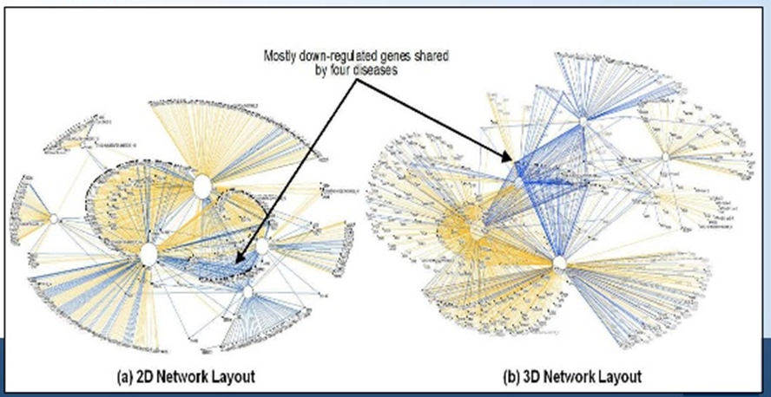
Figure 1.1 Difference between 2D and 3D visualization[9]
The key problem is to implement a 3D metaphor for social media data that is capable of producing information for aiding data analysis. Metaphors are implemented over a half of decades in the computer world. When it comes to the metaphors that use in social media data visualization it is still a new area to explore and to study. Researchers are now focusing more on social media data visualization because there are now endless sources available in all over the internet[6], [10]–[13].

1.2 Research Problem and Research Questions

The goal of this study is to investigate and develop a 3D metaphor for interactive visual analytics of social media data. The general definition of visual metaphor is the representation of a person, place, thing, or idea using a visual image that suggests a particular association or point of similarity. This work focuses on the use of metaphor for social media data exploration. That can be used to analyze the social media data through the 3D interface.
Considering research goal of this study, the generated research questions are as follows:
- How to visualize social media data using a 3D metaphor?
- What is the mechanism to visualize data in 3D space using geolocation?

1.3 Justification for the research

Wang Lidong stated that still there is a need for an interactive and user engage 3D visual analytic tools for social media data [1]. These day researchers are interested in 3D visualization in social media data [14]. In the present most of the analytic tools use 2D visualization, details that represent in 2D visuals are less than 3D that is why researchers are now trying to do 3D visualization in social media data.
Visualization plays a key role in exploring and understanding large datasets. According to[6], 3D visualization has more effects than 2D visualization when it comes to data visualization. Wang et al. states [1], interactive visualizations can help gain great insight from big data, and more new methods and tools of Big Data visualization should be developed for different Big Data applications. From [1], [5]–[7], [14] it is proved that there is a need in social media data 3D visualization.

1.4 Methodology

Recently, there are some researchers carried out to facilitate interactive visualization [6], [7]. As the first step of the research approach these existing approaches to 3D metaphors, data visualization with geolocation and social media data visualization is analyzed, and the key findings of those approaches that can be taken into consideration are identified. Twitter API data study and understanding is carried out as the next step of the research approach. Preprocessed twitter data to compatible with the 3D metaphor. Implement a 3D metaphor to map twitter data based one geolocation is the next step of research approach. The final step is focused on creating a user based evaluation model for the implemented 3D metaphor. Figure 1.2 represents a high-level architecture of the proposed research methodology.

Figure 1.2 High-level architecture of proposed research methodology

1.5 Outline of the Dissertation

The dissertation is structured as follows. Chapter two explores the existing approaches related to the domain of social media data 3D visualization and 3D metaphors. Chapter three describes the proposed research design and methodology. Potential ways of addressing the research problems are discussed in this chapter. Chapter four demonstrates the implementation details of the proposed methodology. Chapter five presents the evaluation model and the evaluation results of the proposed approaches. The last chapter, chapter six demonstrates the conclusion of the thesis and outlines the future work.

1.6 Delimitations of Scope

- In this research, the main deliverable will be an Interactive Metaphor for 3D Visualization of Social Media Data.
- Twitter data will be used as the social media data and data will be gathered from the Twitter API.
- The developed 3D metaphor can be used to visualize Twitter data based on geolocation.
- Drill down mechanism is limited for 3 levels. World map -> Country -> Province / State

1.7 Summary

This chapter laid the foundations for the dissertation. It introduced the research problem and research questions and hypotheses. Then the research was justified, definitions were presented, the methodology was briefly described and justified, the dissertation was outlined, and the limitations were given. On these foundations, the dissertation can proceed with a detailed description of the research.

Literature Review
In this section, a review of related work on social media 3D metaphor for interactive visual analytics of social media data is provided. We have broken down this area into two sub-areas, 3D metaphors, and social media data visualization. Because this research is mainly based on the mentioned sub areas.
Researchers [1], [5], [14], [15] in this field have acknowledged 3D visualization is the next era of visualization. Because it is better than 2D visualization in many ways. When it comes to big data 2D visualization is not enough to do a good analysis and take decisions. People think if we can use 3D visualization to big data it will help to make sense of the structure and underlying patterns that may be held within the data, even before any serious computation begins.
At present, there are several tools to analyze social media data, however, most of them provide a 2D visualization. As an example, "gephi” is software platform which has features for Social Network Analysis, Biological Network analysis in graphical view but all graphs are in 2D.
When it comes to 3D metaphors, it used in many fields not only in the big data[16]–[20]. Gordon. R has tried to introduce a prototype called "Amaze," which is a graphical user interface for an object-oriented database. This 3D interface, helps the user to visualize query construct and result representation [15]. Even though this was a good approach when we consider from the database side, it is not much good from user-friendly and user interface area because the resulting graphic is a little bit complex to understand.
Zachary et al. [14] have done a social media research, where a 3D print was carried out using big data at MIT labs. They have used a 3D mockup of the MIT campus to display twitter data. This data set will be mined to display data that may be important for administrators at MIT who wish to know about patterns on campus through key-word searches and topic clustering. Since they have implemented this only for MIT campus area, it is hard to generalize this project to other areas.
Moran Andrew et al. [6] has done a virtual reality research using twitter social media data. In there they have used MIT campus area as a virtual environment, and they have mapped the geolocation with twitter location data. However, in my point of view the work they are doing is not usable, what they do is just build a virtual environment of MIT campus add some tweets that extracted from the Twitter API and when a user goes to that location just shows that. I think it will be good if they used district as the environment. Because it will be easy to analyze the data, like how data has been scattering around the area.
Alfredo et al. have done some researches for software 3D visualization. In there they try to explain the initial perception of how software is structured, understand the software logic. From this also what we can tell is 3D visualization is doing a major role when it comes to analysis [16]. However, in this project, they have not mentioned how we can use this for software productions. Also, this 3D city is not the best metaphor for this. Because there are so many functions in the software and the outcome will be a very complex one with many blocks. Thus, the user will face a hard time by understanding each block.
Researchers [7] have used social media data for 3D modeling as well. Since there were so many data in social media Abdullah et. Al. has done a research base on following area 3D model places using social media data and drone videos. Here they have used social media data to get missing photo angles of the places. From combining drone videos and social media data, they were able to build good quality 3D models in places [7]. One drawback I see here is that we cannot expect to have the exact missing images in the available social media data.
Ekaterina et al. [5] explained how we could use virtual reality and augmented reality in bid data visualization. In here they have explained 3D visualization is better than 2D visualization when it comes to big data.
Above reviews are mainly based on 3D metaphors and how to apply 3D metaphor for social media visualization. In this study, we only focus on the Twitter dataset. This is only for the evaluation purpose. Below reviews are based on Twitter data visualization and data visualizing on geospatial context.
Andrei Sechelea [21] has done a research very recently about twitter data visualization. In this they have focused on two areas, present a clustering algorithm capable of identifying the main topics of interest in a tweet dataset and to design a visualization method which allows following the intensity of Twitter activity at a given geographical location. For our study, visualization part is important. From this research, we acquire the knowledge of how to do the twitter data preprocessing and what are the difficulties will face on that stage. However, in visualization part, they have only focused on the static 3D geolocation interface. Their interface is not interactive, which interactive interface is one of our main key points. However, we have to admit their research is good. Also, we got some foundation to our research from some of their findings.
Joseph Kaye who is a member of Nokia Research Center has built a system called Nokia Internet Pulse based on his research [22]. Visualizing current discussion around a particular topic on Twitter, this the main focus area of their research. This a not a 3D visualization, they study tweets on a particular period, and they display the most trending word. This is good for getting an idea about that happens at the moment, but we cannot do any analytic part from that.
When it comes to data visualization in a geospatial context, many researchers [8], [13], [21], [23], [24] have focused on that area. Zhiyuan Zhang has done research [18] base on visualizing climate research data in a geospatial context. This an interactive visual analytics framework. They used google earth as their geospatial context and map the climate data on that. They did not implement any 3D metaphor they implement a visually interactive framework with climate data. From this research gained the knowledge of how to map database geospatial context.

Design

3.1 Introduction

This chapter follows the detailed explanation and justification of the mentioned research methodology in Section 1.4. It consists of four major sections namely data acquisition, data preprocessing, 3D visualization, and evaluation.

3.2 Data Acquisition

This section contains the data acquisition process for the 3D metaphor. Main data collection source is the Twitter REST API. Then, a harvesting machine is built to store the collected twitter responses. Collected data is stored in a JSON file to use in future steps. Figure 3.1 represents the high-level diagram of the main component of the data acquisition stage.

Data Acquisition

Figure 3.1 Data acquisition diagram

3.2.1 Twitter REST API

Twitter is a micro-blogging platform, and it has become a key platform for communication. It has evolved into a global scale platform where people discuss day to day serious matters. This is one of the main reason to select twitter data as the data set of this research. Twitter tweets can only have 140 characters; people cannot post lengthy unwanted content in tweets, this another reason to select twitter data. Supporting geo-tagged tweets is also another reason for the selection of twitter data.

Twitter provides four different REST APIs for the developer. The free version of the Twitter Search REST API is the one used for this research. It provides enormous information attribute about a tweet. Figure 3.2 represents a sample twitter response; some attributes are removed and contains only the attributes necessary to the research. Full twitter contains in appendix B.

From the twitter response, geo, place, text, and username are the attributes concern in this research. Geo attribute is the most important attribute for the research; it contains the geolocation the tweet came from. Place attribute contains the country, state/province and the polygon coordinates of the area. Text attribute contains the tweet content. User -> name include the name of the twitter user.

- {
- quote_count: 0,
- text: "Nancy at the Junior Lions Christmas party ❤️ @ Millwall Football Club https://t.co/MIQc8QPqOV",
- id: 942402412068745200,
- coordinates: {
- type: "Point",
- coordinates: [-0.05367,51.48584]
- },
- user: {
- statuses_count: 30295,
- description: "South Londoner born and bred. Millwall season ticket holder & I fear no foe! Chartered Surveyor and dedicated cat lover",
- name: "Jayne Jacob",
- lang: "en",
- screen_name: "jezebeljayne",
- },
- geo: {
- type: "Point",
- coordinates: [
- 51.48584, -0.05367
- ]
- },
- place: {
- full_name: "Lewisham, London",
- country: "United Kingdom",
- place_type: "city",
- bounding_box: {
- type: "Polygon",
- coordinates: [
- [
- [-0.074547,51.414087],
- [-0.074547,51.494127],
- [0.038567,51.494127],
- [0.038567,51.414087]
- ]
- ]
- },
- country_code: "GB",
- attributes: {},
- id: "58f909abfd95e133",
- name: "Lewisham"
- }
- }
Figure 3.2 Sample twitter response

3.2.2 Harvesting Machine

Harvesting machine is a simple application implemented using python to extract tweets from the Twitter API. Extracting tweets for a particular hashtag is the main functionality of this application. It does not give any meaningful view by mapping tweets that related to various areas. This is the reason to do a hashtag-based extracting from Twitter API. This research considered the hashtags with sports names. That is only for the demonstration purpose. The key areas that visualize in the 3D metaphor depend on the users perspective; the user can change the hashtag or user can give a data set that follows the JSON file format mentioned in chapter 3.3 by ignoring this harvest machine.

3.2.3 Data JSON

This file contains the all extracted twitter responses in JSON format. This is the file that used in data preprocessing stage. It is easy to work with JSON file than working with a database and can customize the JSON file format easily. Creating a JSON file requires less work than maintaining a database. To preprocess data it needs to give a data set in JSON format. Retrieving data from the database and converting them into a JSON format creates unnecessary work.

3.3 Data Preprocessing

Twitter API response includes many attributes that are not needed for this research. Removing those attributes is the main action at this stage. As mentioned in section 3.2.1, this research only needs the geo, place, text and user attributes. Figure 3.3 represents the data preprocessing diagram.

Figure 3.3 Data preprocessing diagram

According to Figure 3.3, the final output of the preprocessing stage is a JSON file which contains preprocessed twitter responses (tweets). In this preprocessing stage converting a twitter response mentioned in Figure 3.2 into a twitter, response showed in Figure 3.4 is carried out. In this, icon attribute will add to the response. From the icon attribute, we can decide the icon related to a particular tweet. Value of this attribute decides base on the hashtag if the hashtag is football icon attribute value will be football. In the final twitter respond it only contains the geo, place, text and user attributes.

- {
- text: "Nancy at the Junior Lions Christmas party ❤️ @ Millwall Football Club https://t.co/MIQc8QPqOV",
- user: {
- name: "Jayne Jacob",
- lang: "en",
- screen_name: "jezebeljayne",
- },
- geo: {
- type: "Point",
- coordinates: [
- 51.48584, -0.05367]
- },
- icon: "football"
- place: {
- name: "Lewisham",
- city: "London",
- country: "United Kingdom",
- place_type: "city",
- bounding_box: {type: "Polygon",
- coordinates: [
- [
- [-0.074547,51.414087],
- [-0.074547,51.494127],
- [0.038567,51.494127],
- [0.038567,51.414087]
- ]
- ]
- }}}
Figure 3.4 Preprocessed twitter respond

3.4 3D Visualization

Mapping the tweets into interactive 3D metaphor based on geolocation is the main functionality of this stage. This stage consists of three major components of implementing the 3D metaphor, mapping tweets in metaphor and visualizing the mapped data. 3D metaphor comprises a drill-down mechanism. First state user sees the world map and how the tweets are distributed within the countries in the world. By selecting a country, the user can drill down into the country stage. In a country view, the user will see the tweets distribution within the states or provinces.

“Using concepts familiar to users may require less training time because users can intuit primary attributes of structure or processing” [25]. All the icons designed for the metaphor follows this statement.

3.4.1 Implementing 3D Metaphor

This research use leaflet JS and eeGeo JS map to implement 3D map. Leaflet JS provides APIs to add markers and areas to the map. eeGeo js provides the 3D functionality to map by using WebGL. Using eeGeo turn the 2D map into 3D map. Underline of the eeGeo map is leaflet JS.

Implemented interactive 3D metaphor consists of several features. The drill-down mechanism is a feature. Filter menu is the other important feature. Filter menu provides interactive buttons according to the extracted twitter hashtag values. For example, final twitter dataset (tweets) consists of tweets related to sports, and the extracted hashtag values are football, tennis, and cricket. Then the filter menu has three buttons with following names football, tennis, and cricket. Button icons are same as the mapped tweet icons. Filter menu appears from the right side of the map.

3.4.2 Mapping Tweets

This is the stage that preprocessed data mapped into the 3D metaphor. Tweet mapped icon decide base on the icon value as mention in section 3.3. All icons are related to the particular sports name. From that, user’s eyes and mind will adjust to icons since people are familiar with sports equipment. Little children also can identify the sport by looking at the sports equipment. The icons used in the research can be identified by the small children as well. Figure 3.5 represents the icons used to map tweets.
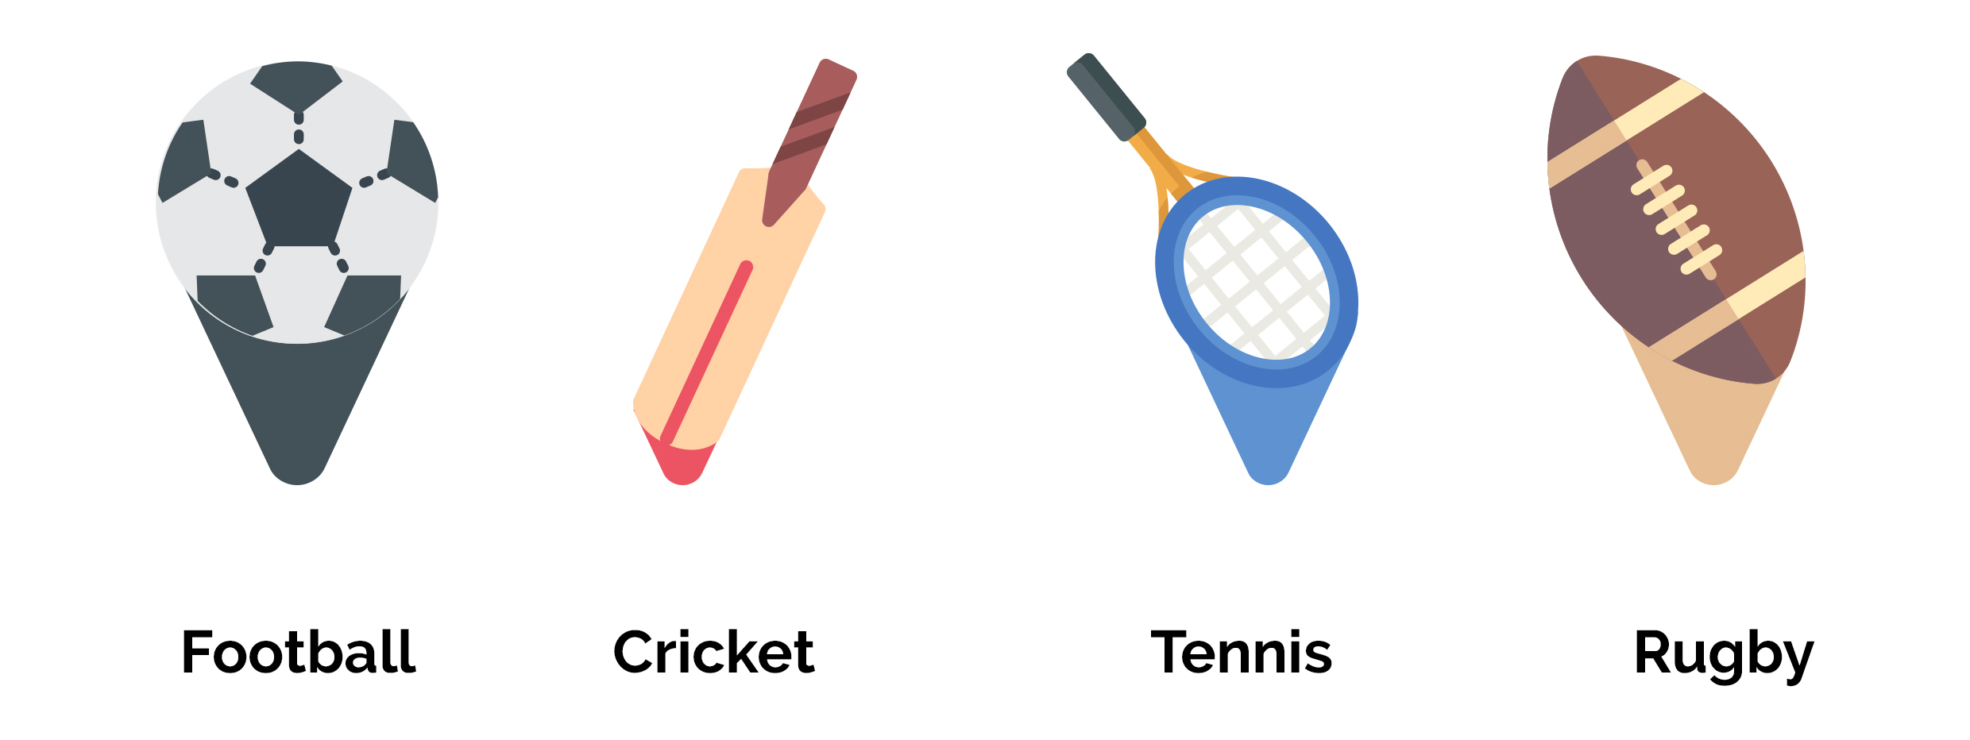
Figure 3.5 Tweets mapping icons chart

3.4.3 Visualizing

Implemented interactive 3D metaphor can be visualized using any web browser that supports WebGL. Visualize interface is not mobile responsive therefore a desktop browser is required. Nowadays everyone has access to a web browser; it is easy to use and very simple to handle. No need any extra equipment to display 3D in the browser, using WebGL we can do it simply. Final user interfaces can find in chapter 4 – implementation.

3.5 Evaluation

This research used a qualitative method to evaluate the implemented 3D metaphor. Evaluation purpose is to identify the implemented 3D metaphor is suitable to display twitter data. A method carried out openly via the internet; a google form has shared with participants and participants are anonymous. The form contained in the all instructions and evaluation model. All participants had a chance to interact with a 2D metaphor and 3D metaphor which has hosted on the internet. After that evaluation carried out based on the participants, experience had in two metaphors and ratings given by the participants.

3.6 Summary

This chapter provided a detailed description of the research design and the approaches considered in this study to build an interactive 3D metaphor for social media data. Research design composed of four main components which are data acquisition, data preprocessing, 3D visualization, and evaluation. Data acquisition section describes the way that collected and stored. Data preprocessing section includes the mechanisms used to preprocess data. 3D visualization section describes the approaches used to visualize Twitter data in a 3D space. Evaluation section contains how the evaluation was carried out to build metaphor.

Implementation

4.1 Introduction

This chapter reviews the implemented user interfaces (UIs) and the significant functions. All UIs are implemented using javascript, HTML, and CSS. UIs are not responsive; it can only view using a desktop web browser. Throughout this chapter explain how to interact with UIs and the functionalities of each UI components. End of the chapter elaborates the significant functions like data extraction and preprocessing.

4.2 Implementation

User interfaces design to align with the study purpose, which helps to social media data analysis. Figure 4.1 shows the initial UI that user gets once the user load proposed 3D metaphor in the web browser.
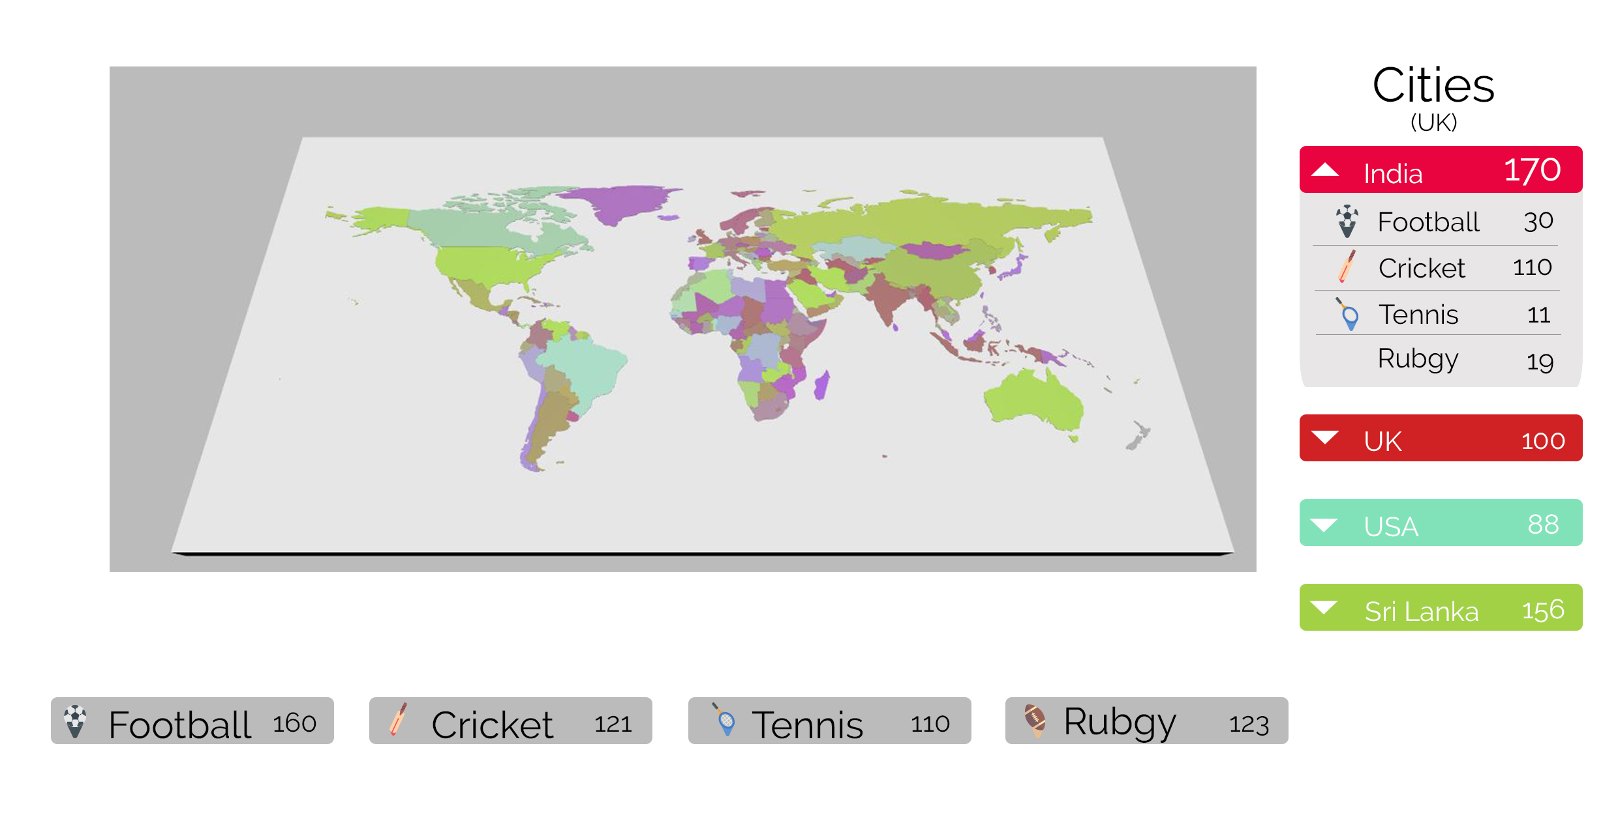
Figure 4.1 Initial user interface
In this UI shows the view of a world map, countries colored with some random colors. Right side shows the tweets count for each country. Bottom bar shows the total tweets count for each hashtag value. This study used the twitter data that includes sports name in the tweets hashtags. Clicking one of a right side country can the break down to values for each hashtag value.
Clicking a country on a world map will take the user into the country interface. Right side menu and the bottom values will change according to the country. The right side menu will change to main cities/states or provinces. This depends on how the Twitter API place attribute. In-country view the user will get a menu in the bottom also, from the bottom menu user can choose what hashtag related tweets should visualize on the metaphor. The user can select to visualize all hashtag values related tweets as well; default enables this. Figure 4.2 shows the Interface of country view.
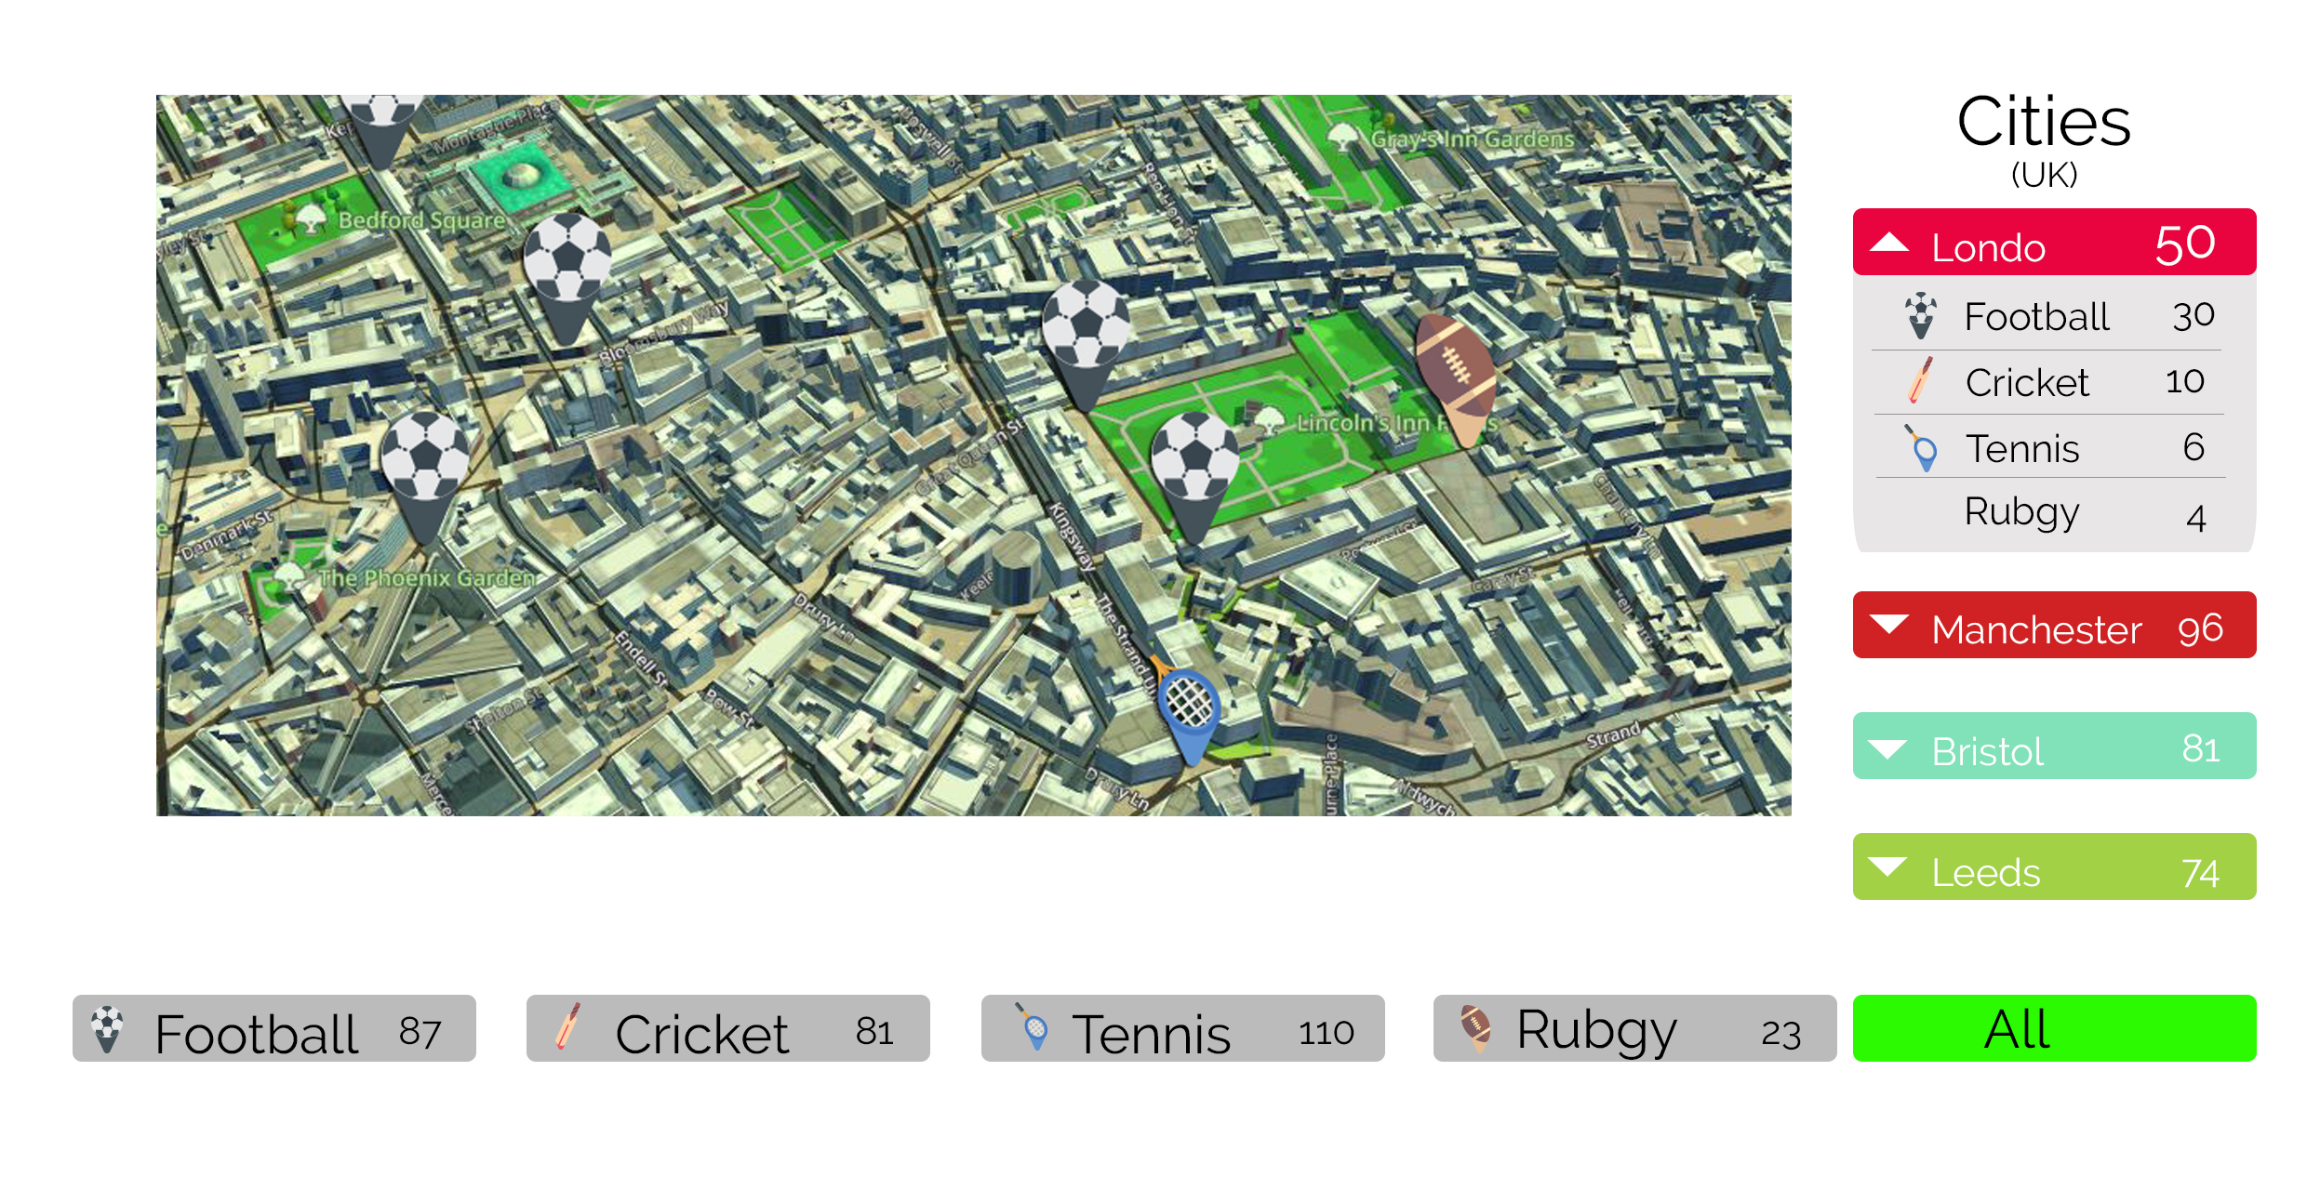
Figure 4.2 Interface of country view

To build the 3D map which can view on a web browser, used the eeGeo JS library. eeGeo JS is still evolving library; it does not support 3D view for some countries still. eeGeo JS render the 3D view on top of the leaflet JS, that is an advantage for this study. Adding a marker and polygon areas can be done easily by using leaflet JS. Figure 4.3 shows how to add the eeGeo JS for the project. Need to add the CSS file of the leaflet JS as well.
<link rel="stylesheet" href="https://unpkg.com/leaflet@1.0.3/dist/leaflet.css" />
<script src="https://cdn-webgl.eegeo.com/eegeojs/api/v0.1.780/eegeo.js"></script>

Figure 4.3 Import eeGeo JS
Harvesting machine application used a python function to extract data from Twitter API. To extract data from Twitter API need to have a twitter application token that gains from creating a developer account in twitter developer console. Figure 4.4 shows the harvesting function used in this study. Python tweepy library used to extract data from Twitter API. Full code segment contains in appendix B.

def main():
try:
global api
logger.info("Authorizing with Twitter")
l = StdOutListener()
auth = OAuthHandler(consumer_key, consumer_secret)
auth.set_access_token(access_token, access_token_secret)
logger.info("Authorized Twitter")
api = API(auth)

stream = Stream(auth, l)
stream.filter(track=["football"]) ##hashtag to retrieve

except Exception, e:
logger.debug('%s, %s ' % (sys.exc_traceback.tb_lineno, e))

Figure 4.4 Python function for tweets extraction
Extracted twitter have preprocessed using a javascript function. From this function, it takes only the useful attributes of this study from twitter response and returns it as a JSON object. Figure 4.5 shows the preprocessing function used in this study. This function extracts the coordinates, user, geo, place, and text attributes from twitter response and adds the new attribute call icon, value of this attributes depends on the response hashtag.
function dataPreprocces(file) {
var preProccessedDat = {};
$.getJSON(file, function(data) {
$.each(data, function(key, val) {
var tweetResponse = {};
if (key == coordinates) {
tweetResponse += {key : val};
}if (key == user) {
tweetResponse += {key : val};
}if (key == geo) {
tweetResponse += {key : val};
}if (key == text) {
tweetResponse += {key : val};
}if (key == place) {
tweetResponse += {key : val};
}if (key == hashtag) {
tweetResponse += {"icon" : val};
}
preProccessedDat += tweetResponse;
});
});
return preProccessedDat;
}
Figure 4.5 Data preprocessed function
Leaflet JS support custom markers, using that creates the custom markers for all hashtag values. To map markers in 3D map used the addMarkers function. This function takes a tweet as an input and based on the tweet icon value it decides the marker and assigns the marker coordinates that comes in the tweet. Figure 4.6 shows how to create a custom marker in leaflet JS and figure 4.7 shows the addMarker function used in this study.

var tennisIcon = L.icon({
iconUrl: 'tennis.png', //image for the marker
iconSize: [32, 32],
iconAnchor: [22, 94],
shadowAnchor: [4, 62],
popupAnchor: [-3, -76]
});
Figure 4.6 Create custom marker in leaflet JS

function addMarker(tweet){
if(tweet.icon == "tennis"){
L.marker([tweet.coordinates[0], tweet.coordinates[1]],{icon: tennis}).addTo(map);
}

else if(tweet.icon == "cricket"){
L.marker([tweet.coordinates[0], tweet.coordinates[1]],{icon: cricket}).addTo(map);
}
else if(tweet.icon == "football"){
L.marker([tweet.coordinates[0], tweet.coordinates[1]],{icon: football}).addTo(map);
}
else if(tweet.icon == "rugby"){
L.marker([tweet.coordinates[0], tweet.coordinates[1]],{icon: rugby}).addTo(map);
}
}
Figure 4.7 addMarker function

4.3 Summary

This chapter contain the detailed explanations for user interfaces used in the proposed interactive 3D metaphor and the detailed descriptions for significant functions that in the code base.

Results and Evaluation

5.1 Introduction

This chapter reviews how the evaluation was conducted for the implemented interactive 3D metaphor and the results that gained from the evaluation. To evaluate the metaphor, a qualitative evaluation method using online participants was carried out. Section 5.2 elaborates on this evaluation model. Final results and the outcomes of the evaluation are discussed in section 5.3.

5.2 Evaluation Model

The qualitative method used for the evaluation was carried out as follows. The participants were given a chance to experience a 2D metaphor and a 3D metaphor (which proposed by this research). Both metaphors visualized the same tweets and the same icons. After that, participants were asked to fill a survey form under the consideration of the following key features. All key features are rated using a 1 to 5 scalar. one is the lowest value, and five is the highest.
- Easy to understand – how easy to understand the data representation of each metaphor.
- Interactiveness – interactiveness by the experience gained through each metaphor.
- Good for analyzing purpose – how good to use each metaphor for analysis purpose.
- User friendliness – users, rated the user-friendliness according to the user perspective. The main purpose of this is to understand does the implement 3D metaphor is user-friendly to use.
The main purpose of carrying an online survey is to have a variety of participants [16]. Doing this using only university students or within the university cannot achieve the purpose of having variety between participants.

To have a better idea of the participants, survey form also collected participants gender and age range. Participants also got a chance to give any feedback for the implemented 3D metaphor and feedback for the research. In the end, participants were asked to select which metaphor is more suitable for twitter data visualization. This question was asked at the very end after the rating all key features and the feedback section. Participants were also asked to rate tweet mapped icons. Not good, good, very good are the scalar values used for that rating. Full survey form structured contains in appendix A.

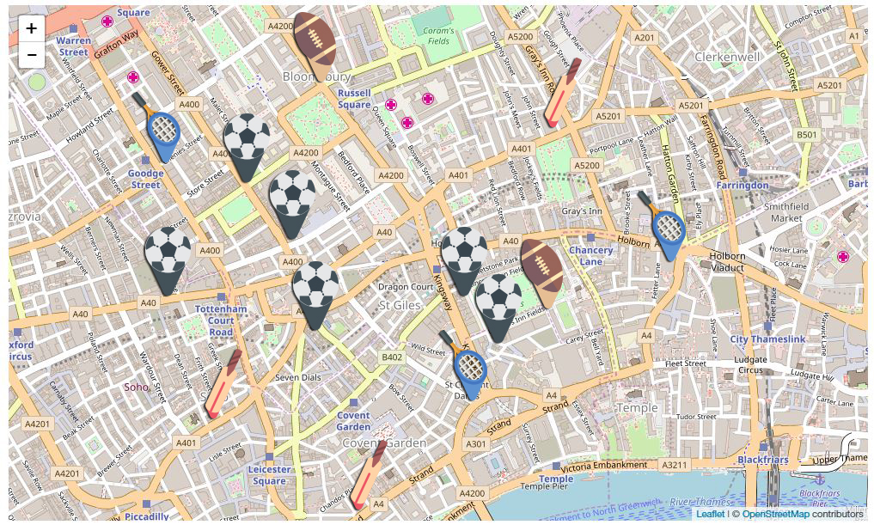
Figure 5.1 shows the 2D map participants experience in the survey. Figure 5.2 shows the same map after several zoom levels. The only way that a participant can interact with the 2D is to zoom in and out.

Figure 5.1 2D map used in evaluation survey
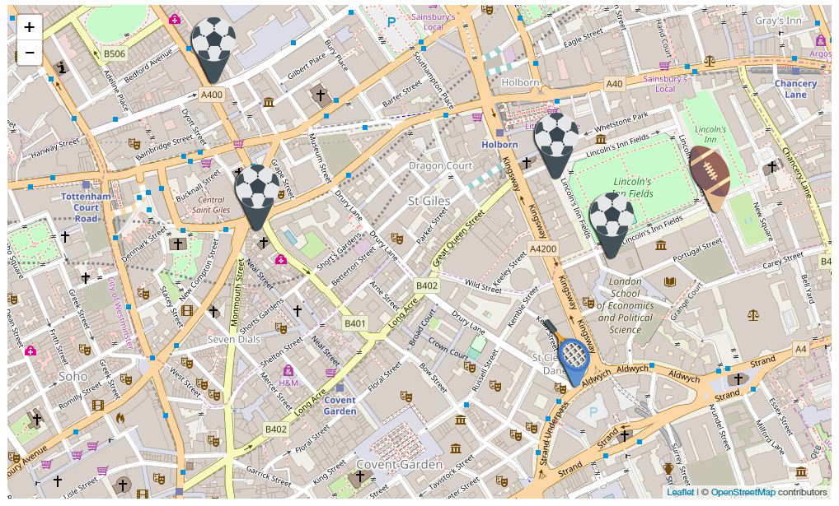
Figure 5.2 2D map after several zoom levels
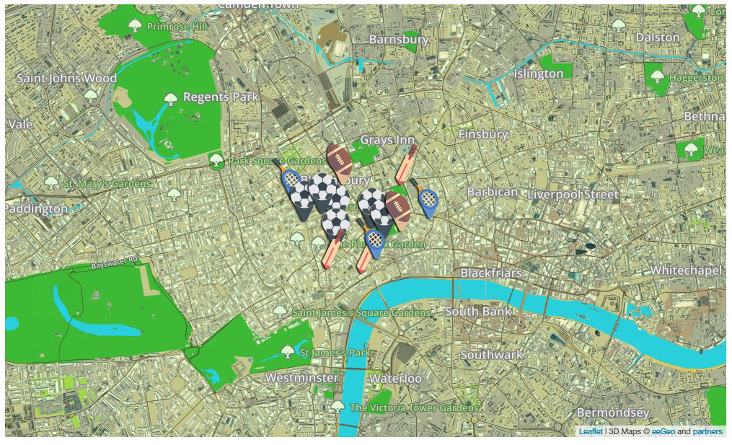
Figure 5.3 shows the 3D map participants experience in the survey. Figure 5.4 shows that map after several zoom levels. The used 3D map has rotation interact activity with zoom in and out. It is more colorful than the 2D map.
Figure 5.3 3D map used in evaluation survey
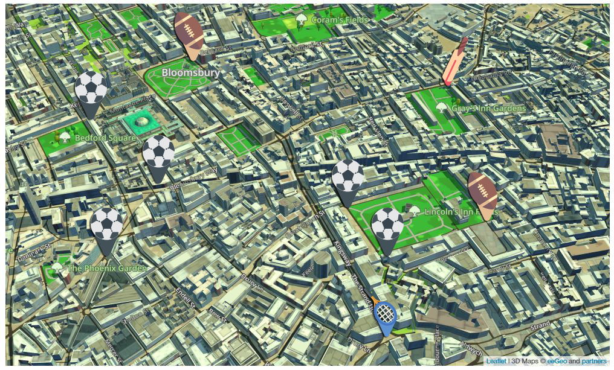
Figure 5.4 3D map after several zoom levels

5.3 Results

At the end of the survey period, 37 participants have completed the survey. There was no time limit to complete the survey and participants can take as much as the time they need to experience the metaphors.

There were 24 male participants and 13 female participants among the participant population. Figure 5.5 represents the gender-based statics graph.
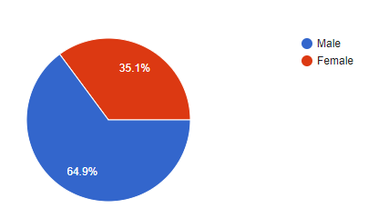
Figure 5.5 Gender statics graph
Most of the participants are from the age group of 20-25. Figure 5.6 represents the age group statics graph.
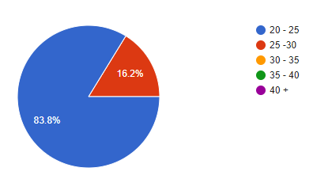
Figure 5.6 Age group statics graph

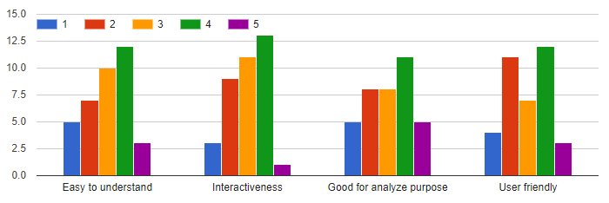

Figure 5.7 Feature rating graph for 2D metaphor
Most of the participants have good ratings for the 2D metaphor which used the 2D map. For all key features, most of participates have rated scale 4. This indicates the 2D metaphor is also good for twitter data representation. Figure 5.7 represents the user rating statics for the key features of the 2D metaphor.
When it comes to 3D metaphor, it has more scale 5 ratings for key features when compared with the 2D metaphor feature rating graph. Figure 5.8 represents the key feature rating graph for the 3D metaphor.

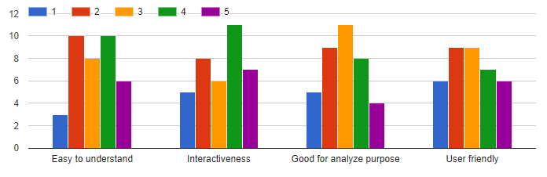
Figure 5.8 Feature rating graph for 3D metaphor
When it comes to select a suitable metaphor to visualize twitter data, more than 50% participants have rated the 3D metaphor is more suitable than the 2D metaphor. Figure 5.9 represents the statics graph for metaphor rating.
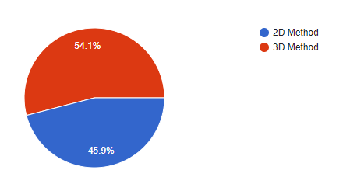
Figure 5.9 Metaphor rating statics graph
Most of the participants have rated the used icons are good for visualization. Few participants have rated icons are not suitable (not good) for visualization. Figure 5.10 represents the icon rating statics graph.

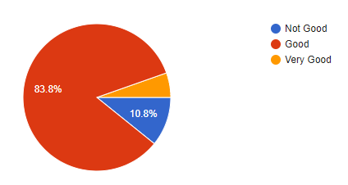
Figure 5.10 Icon rating statics graph

When it comes to 3D map loading time most of the participants have complained that loading time is very high for the 3D metaphor. This is mainly because the 3D metaphor has more details than the 2D one. Resolving this issue direct to another research area. That is out of scope for the current research.

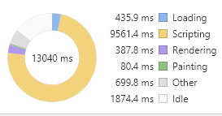
As additional testing, a google chrome performance testing for both 2D and 3D metaphor was conducted. It indicates that 3D metaphor takes much time to load scripts than a 2D metaphor. Mainly because eeGeo use a large number of scripts to build the 3D map on top of the leaflet JS map. Figure 5.11 shows the google chrome performance testing results for the proposed 3D metaphor and Figure 5.12 shows the results for 2D metaphor.
Figure 5.11 Performance testing results for 3D metaphor

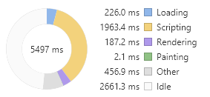
Figure 5.12 Performance testing results for 2D metaphor

5.4 Summary

This chapter explained the proposed evaluation model to evaluate proposed interactive 3D metaphor for visualizing social media data. Section 5.2 explained the qualitative evaluation method conduct to evaluate implemented interactive 3D metaphor under the case study of visualizing twitter data which includes the sports name in the hashtags. Evaluation results are explained in section 5.3. Further analysis showed that people are more like to 3D metaphor than a 2D metaphor.

Conclusions

6.1 Introduction

The purpose of the current study was to implement an interactive 3D metaphor to visualize social media data to help social media analysis. This chapter will review the conclusions of this study based on the mentioned purpose and limitations of the current work. The final section discusses the future enhancements for the current study.

6.2 Conclusions

This study has shown that people are more like to visualize data in 3D space than 2D space. Analytics of the evaluation results have proved that. However, the analytics of the results also show that 2D metaphor are also good for data visualization, and there are people who like to interact with 2D metaphors.

The results of this study indicate that implemented 3D metaphor is suitable to visualize social media data, in this case, twitter data. However, from the participants comments, it indicates that still there are more improvements to be done in proposed 3D metaphor. Appendix A-participants comments diagram contains all participants comments.

The results of this research support the idea that people are like to analyze data using a 3D metaphor and it is interesting when it compares with the 2D metaphors.

This study shows that mapping data based on geolocation can improve the visualization of data representation. The present study has introduced a new 3D metaphor to visualize social media data. This is the main contribution to the data visualization and analytics field.

However, researchers can implement more suitable interactive 3D metaphors to visualize social media. It is possible that someone has already started to implement a new metaphor to visualize social media data in a 3D space. That is the significant learning learned while doing this study. Metaphors are not a new thing to the computer world. Over the half century, the development of these metaphors changed dynamically [25]. Metaphors cannot limit the web 3D interface. It has a broad view and a long future.

6.3 Limitations

- The current investigation was limited twitter data visualization. The current study was unable to visualize other social media platform data.
- The user interface is not mobile responsive. Implemented 3D metaphor can only be used in the desktop web browser.
- Only have three drill-down levels.

6.4 Implications for further research

This research has opened up many paths to consider in future. The current 3D metaphor is controlled from the mouse and keyboard. This can be improved where metaphors are controlled from hand gestures. Nowadays there are several motion tracking devices; one such device can be used for this scenario.
It would be interesting to implement this web-based 3D metaphor in a virtual environment. Users can explore the cities in a virtual environment and can analyze the data by getting real-life experience.
Mobile screen interface designing and metaphors are different than in desktop. Therefore there is a need to improve this metaphor to be compatible with the mobile phones.

References
[1] L. Wang, G. Wang, and C. A. Alexander, “Big Data and Visualization: Methods, Challenges and Technology Progress,” Digit. Technol., vol. 1, no. 1, pp. 33–38, 2015.
[2] C. Ware, Visual thinking for design. Morgan Kaufmann, 2008.
[3] C. A. Blok, U. D. T. Turdukulov, R. Zurita-Milla, V. Retsios, M. Schouwenburg, and M. Metaferia, “Development of an Open-Source Toolbox for the Analysis and Visualization of Remotely Sensed Time Series,” Cartogr. Int. J. Geogr. Inf. Geovisualization, vol. 46, no. 4, pp. 227–238, Dec. 2011.
[4] J. J. . C. K. A. Thomas, “Illuminating the Path: The Research and Development Agenda for Visual Analytics,” 2005.
[5] E. Olshannikova, A. Ometov, Y. Koucheryavy, and T. Olsson, “Visualizing Big Data with augmented and virtual reality: challenges and research agenda,” J. Big Data, vol. 2, no. 1, p. 22, 2015.
[6] A. Moran, V. Gadepally, M. Hubbell, and J. Kepner, “Improving Big Data Visual Analytics with Interactive Virtual Reality,” 2015 IEEE High Perform. Extrem. Comput. Conf. (HPEC ‘15), pp. 0–5, 2015.
[7] A. Bulbul, “Social Media based 3D Modeling and Visualization,” vol. 32, no. June 2013, p. 2015, 2015.
[8] M. Graham, S. A. Hale, and D. Gaffney, “Where in the world are you? Geolocation and language identification in Twitter.”
[9] “MLA CE: The Diversity of Data Management: Practical Approaches Record….” [Online].Available:
https://www.slideshare.net/umhealthscienceslibraries/mla-ce-the-diversity-of-data-management-practical-approaches-recorded-webcast-nov-11-2016-marci-brandenburg-68908478. [Accessed: 18-Dec-2017].
[10] Q. Dex et al., “An effective approach for visualizing big data,” vol. 7, no. 2, pp. 77–81, 2016.
[11] S. Dipaola and D. Collins, “A Social Metaphor-based 3D Virtual Environment,” pp. 2–6.
[12] V. Snel, J. Nowakov, F. Xhafa, and L. Barolli, “Geometrical and topological approaches to Big Data,” Futur. Gener. Comput. Syst., vol. 67, pp. 286–296, 2017.
[13] Z. Zhang, X. Tong, K. T. McDonnell, A. Zelenyuk, D. Imre, and K. Mueller, “An interactive visual analytics framework for multi-field data in a geo-spatial context,” Tsinghua Sci. Technol., vol. 18, no. 2, pp. 111–124, 2013.
[14] Z. Weber and V. Gadepally, “Using 3D Printing to Visualize Social Media Big Data,” arXiv Prepr. arXiv1409.7724, vol. c, 2014.
[15] R. Gordon, “The Design of 3D Metaphors for Database Visualisation Postgrad Surname Forename Boyle.”
[16] A. Teyseyre and M. Campo, “An Overview of 3D Software Visualization,” vol. 15, no. 1, pp. 1–20, 2008.
[17] A. K. Al-Awami et al., “NeuroLines: A subway map metaphor for visualizing nanoscale neuronal connectivity,” IEEE Trans. Vis. Comput. Graph., vol. 20, no. 12, pp. 2369–2378, 2014.
[18] D. Rodrigues and I. Oakley, “Social circles: A 3D user interface for facebook,” Lect. Notes Comput. Sci. (including Subser. Lect. Notes Artif. Intell. Lect. Notes Bioinformatics), vol. 5727 LNCS, no. PART 2, pp. 838–839, 2009.
[19] F. No??l and D. Dori, “Towards 3D visualization metaphors for better PLM perception,” IFIP Adv. Inf. Commun. Technol., vol. 467, pp. 461–475, 2016.
[20] P. Mahaffy, “Moving Chemistry Education into 3D: A Tetrahedral Metaphor for Understanding Chemistry. Union Carbide Award for Chemical Education,” J. Chem. Educ., vol. 83, no. 1, p. 49, 2006.
[21] A. Sechelea, T. Do Huu, E. Zimos, and N. Deligiannis, “Twitter Data Clustering and Visualization,” vol. 8.
[22] J. Kaye, A. Lillie, D. Jagdish, J. Walkup, R. Parada, and K. Mori, “Nokia internet pulse: a long term deployment and iteration of a twitter visualization,” CHI’12 Ext. Abstr. Hum. Factors Comput. Syst., pp. 829–844, 2012.
[23] B. Meyer, K. Bryan, Y. Santos, and B. Kim, “TwitterReporter: Breaking News Detection and Visualization through the Geo-Tagged Twitter Network.,” Cata, vol. 10, no. January 2011, pp. 84–89, 2011.
[24] D. Thom, H. Bosch, S. Koch, M. Worner, and T. Ertl, “Spatiotemporal anomaly detection through visual analysis of geolocated Twitter messages,” in 2012 IEEE Pacific Visualization Symposium, 2012, pp. 41–48.
[25] A. Marcus, “Metaphor design in user interfaces,” ACM SIGDOC Asterisk J. Comput. Doc., vol. 22, no. 2, pp. 43–57, 1998.

Appendix A: Diagrams
Evaluation form structure.
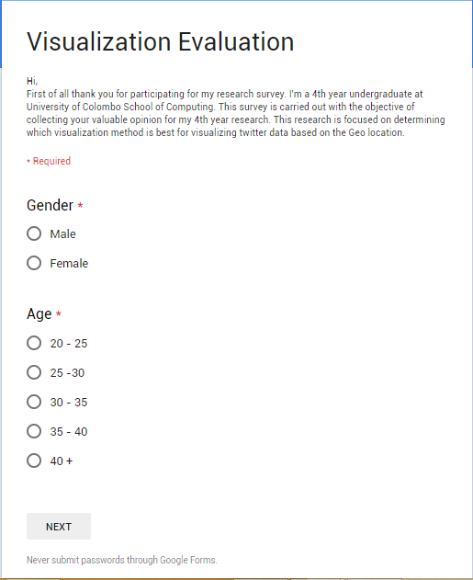
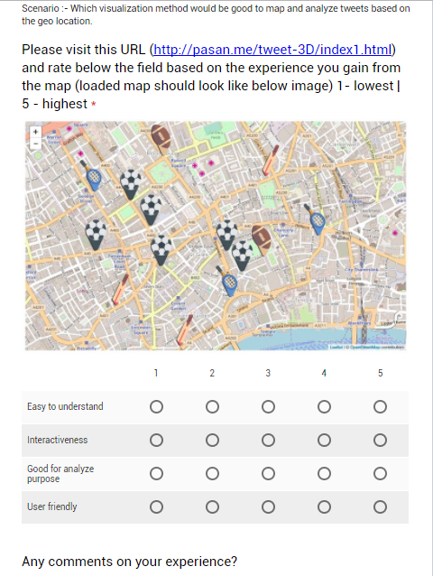
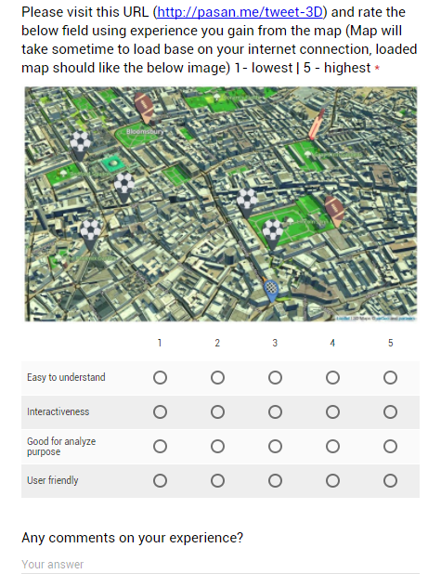
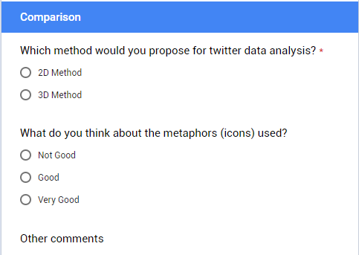
Feedback comments for 3D metaphor.
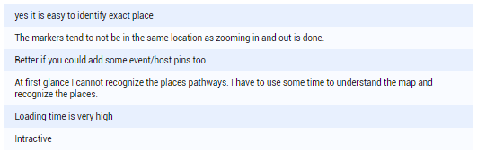
Feedback comments for 2D metaphor.
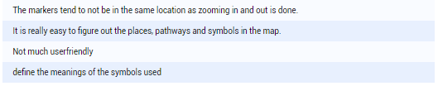

Appendix B: Code Listings
Following figure represents the detailed Twitter response for a tweet.
- {
- quote_count: 0,
- contributors: null,
- truncated: false,
- text: "Nancy at the Junior Lions Christmas party ❤️ @ Millwall Football Club https://t.co/MIQc8QPqOV",
- is_quote_status: false,
- in_reply_to_status_id: null,
- reply_count: 0,
- id: 942402412068745200,
- favorite_count: 0,
- source: "<a href="
- http: //instagram.com" rel="nofollow">Instagram</a>",
- retweeted: false,
- coordinates: {
- type: "Point",
- coordinates: [-0.05367,
- 51.48584
- ]
- },
- timestamp_ms: "1513521218684",
- entities: {
- user_mentions: [],
- symbols: [],
- hashtags: [],
- urls: [{
- url: "https://t.co/MIQc8QPqOV",
- indices: [
- 70,
- 93
- ],
- expanded_url: "https://www.instagram.com/p/Bczo27QHgZ3/",
- display_url: "instagram.com/p/Bczo27QHgZ3/"
- }]
- },
- in_reply_to_screen_name: null,
- id_str: "942402412068745217",
- retweet_count: 0,
- in_reply_to_user_id: null,
- favorited: false,
- user: {
- follow_request_sent: null,
- profile_use_background_image: true,
- default_profile_image: false,
- id: 315426450,
- default_profile: true,
- verified: false,
- profile_image_url_https: "https://pbs.twimg.com/profile_images/885047437269794819/adMCJKp6_normal.jpg",
- profile_sidebar_fill_color: "DDEEF6",
- profile_text_color: "333333",
- followers_count: 2404,
- profile_sidebar_border_color: "C0DEED",
- id_str: "315426450",
- profile_background_color: "C0DEED",
- listed_count: 26,
- profile_background_image_url_https: "https://abs.twimg.com/images/themes/theme1/bg.png",
- utc_offset: null,
- statuses_count: 30295,
- description: "South Londoner born and bred. Millwall season ticket holder & I fear no foe! Chartered Surveyor and dedicated cat lover",
- friends_count: 1912,
- location: null,
- profile_link_color: "1DA1F2",
- profile_image_url: "http://pbs.twimg.com/profile_images/885047437269794819/adMCJKp6_normal.jpg",
- following: null,
- geo_enabled: true,
- profile_banner_url: "https://pbs.twimg.com/profile_banners/315426450/1498312333",
- profile_background_image_url: "http://abs.twimg.com/images/themes/theme1/bg.png",
- name: "Jayne Jacob",
- lang: "en",
- profile_background_tile: false,
- favourites_count: 16585,
- screen_name: "jezebeljayne",
- notifications: null,
- url: null,
- created_at: "Sat Jun 11 21:10:13 +0000 2011",
- contributors_enabled: false,
- time_zone: null,
- protected: false,
- translator_type: "none",
- is_translator: false
- },
- geo: {
- type: "Point",
- coordinates: [
- 51.48584, -0.05367
- ]
- },
- in_reply_to_user_id_str: null,
- possibly_sensitive: false,
- lang: "en",
- created_at: "Sun Dec 17 14:33:38 +0000 2017",
- filter_level: "low",
- in_reply_to_status_id_str: null,
- place: {
- full_name: "Lewisham, London",
- url: "https://api.twitter.com/1.1/geo/id/58f909abfd95e133.json",
- country: "United Kingdom",
- place_type: "city",
- bounding_box: {
- type: "Polygon",
- coordinates: [
- [
- [-0.074547,
- 51.414087
- ],
- [-0.074547,
- 51.494127
- ],
- [
- 0.038567,
- 51.494127
- ],
- [
- 0.038567,
- 51.414087
- ]
- ]
- ]
- },
- country_code: "GB",
- attributes: {},
- id: "58f909abfd95e133",
- name: "Lewisham"
- }
- }

The full code segment for twitter data extraction.
from tweepy.streaming import StreamListener
from tweepy import OAuthHandler
from tweepy import Stream, API
from datetime import datetime
from optparse import OptionParser
import json
import sys
import re
import logging
import logging.config

BIGLIST = []
replied_type = []
api = None # fugly temp placeholder

FILE_CONFIG = 'compli.conf'
LOG_CONFIG = 'logging.ini'

logging.config.fileConfig(LOG_CONFIG)
logger = logging.getLogger(__name__)

### Read configs ###
parser = ConfigParser.ConfigParser()
parser.read(FILE_CONFIG)
section = "Twitter"
consumer_key = parser.get(section, "CON_KEY")
consumer_secret = parser.get(section, "CON_SEC")
access_token = parser.get(section, "ACC_KEY")
access_token_secret = parser.get(section, "ACC_SEC")
### /Read configs ###

class StdOutListener(StreamListener):
def on_data(self, data):
data = json.loads(data)
BIGLIST.append(data)
return True

def on_error(self, status):
logger.debug(status)

def store(data):
logger.info("Storing dump to file")
with open('dump.json', 'w') as fout:
json.dump(data, fout)

def main():
try:
global api
logger.info("Authorizing with Twitter")
l = StdOutListener()
auth = OAuthHandler(consumer_key, consumer_secret)
auth.set_access_token(access_token, access_token_secret)
logger.info("Authorized Twitter")
api = API(auth)

stream = Stream(auth, l)
stream.filter(track=["football"]) ##hashtag to retrieve

except Exception, e:
logger.debug('%s, %s ' % (sys.exc_traceback.tb_lineno, e))

if __name__ == '__main__':
try:
main()
except KeyboardInterrupt:
store(BIGLIST)
logger.debug("Terminating...")

Initialize the 3D map in front end.
<html lang="en">
<head>
<meta charset="utf-8">
<title>Building Gorgeous 3D maps with eegeo.js and Leaflet</title>
<link rel="stylesheet" href="https://unpkg.com/leaflet@1.0.3/dist/leaflet.css" />
<script src="https://cdn-webgl.eegeo.com/eegeojs/api/v0.1.780/eegeo.js"></script>
<style media="screen">
.center {
margin: 0 auto;
}
</style>
</head>
<body>
<div id="map" class="center" style="width: 1000px; height: 600px;"></div>
<div class="center">
</div>
</body>
</html>

